**BEACON FLASHER USING MICROCONTROLLER**

**ABSTRACT**

This project is designed to provide flashing lamp simulating a beacon light generally used in shipyards, sea shores etc. It is also used in middle of the sea to warn ships about the hidden rocks.

A programmable microcontroller from PIC family is engaged to provide flashing light at periodical intervals as per the practice followed at sea shores, shipyards etc. A low voltage lamp of 12V is driven by a power MOSFET in PWM mode which is derived from a microcontroller. The duty cycle of the PWM has to be changed depending on the type of application. As the controller gives only 5v drive, it is not possible for the MOSFET to be reliably switched ON at that voltage. An interfacing transistor is used between the controller output and the MOSFET for driving the same.

Further the project can be enhanced by using a high power 230V lamp in combination with solid state switching for better visibility.

**BLOCK DIAGRAM**

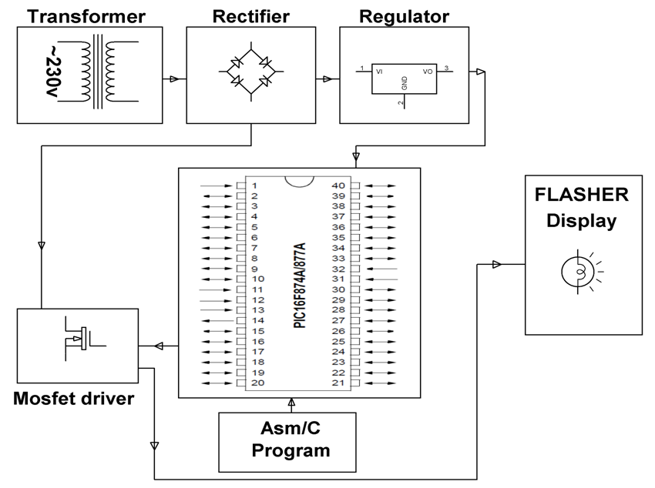

**SOFTWARE REQUIREMENTS:**

HI-TECH PICC Tool suite

Language: Embedded C or Assembly.

**HARDWARE REQUIREMENTS:**

Transformer, Diodes, Capacitors, Resistors, PIC Microcontroller, 12v Lamp, Mosfet, Crystal.